**`**

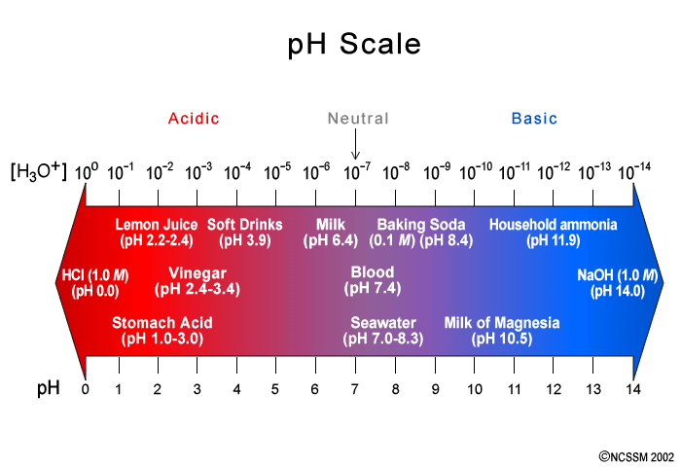

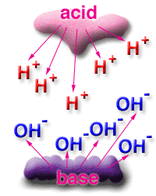**Acids**

**and**

**Bases**

***Textbook:*** Chapter

***Homework:*** ____________

***Exam Dates:***

Free Response: ____________

Multiple Choice: ____________

**Acids, Bases & Salts Study Guide**

**Properties of Acids and Bases**

**Acids:**

* produce H+ ions in water
* aqueous solutions of acids will conduct electricity (are electrolytes and produce ions)
* react with metals (Ex. Zn, Mg) to form H2 gas (any metal above Hydrogen on Chart J will react with acid)
* turn Litmus from blue → red
* taste sour
* [H+] > [OH-]
* are covalent compounds that produce hydronium ions (H3O+) in water
* monoprotic –HCl(aq), diprotic - H2SO4(aq) or triprotic acids - H3PO4 (aq)
* strong acids vs weak acids – Table K

**Bases:**

* aqueous solutions of bases will conduct electricity (are electrolytes due to free ions)
* turn litmus from red → blue
* taste bitter
* are caustic
* feel slippery/soapy
* produce OH- ions (hydroxyl ions) in water
* [OH-] > [H+]
* strong bases (Group 1 and 2 metal hydroxides) vs weak bases

Naming Acids: General formula: HX (See Table K)

* binary acids hydro______ic acid Ex. HCl – hydrochloric acid, HBr – hydrobromic acid, HI – hydroiodic acid
* ternary acids – name the polyatomic ion and change the ending

(-ate → -ic ; -ite → -ous) Ex: HNO3 – nitric acid, H2SO3 – sulfurous acid

Naming Bases**:** General Formula: MOH M= metal + hydroxide (See Chart L)

Arrhenius Theory

* Acids give off H+ ions as the only positive ions. Ex. HCl
* Bases give off OH- ions as the only negative ions. Ex. NaOH

Bronsted – Lowry Theory

* Acids donate a proton (H+) during a reaction
* Bases accept a proton (H+) during a reaction
* Conjugate acid-base pairs (1 reactant, 1 product that differ by one H+)
* strong acids produce weak conjugate bases

weak acids produce strong conjugate bases

* amphiprotic or amphoteric substances: can act like an acid and donate a proton or act like a base and accept a proton.

Indicators

* substances that change color in the presence of acids or bases
* Ex. litmus, phenolphthalein
* pH and the range of color change for indicators – Chart M

Neutralization

* Neutralization reactions:

acid + base → salt + water

* Titrations and end points: MAVA = MBVB  M = molarity V = volume (Table T)
* Hydrolysis reactions:

salt + water → acid + base

(look on table L for strengths of acids, group 1 & 2 metals create strong bases)

pH and the ionization Constant for Water (Kw)

* Kw = 1 x 10-14 = [H+] x [OH-]
* For a neutral solution, [H+] = 1 x 10-7 [OH-] = 1 x 10-7
* pH = -log[H+]
* determining the pH from the [H+]
* determining the pH from the [OH-]

**Vocabulary**

acids

bases

indicators

hydronium ions

litmus

titration

pH

Kw

endpoint

phenolphthalein

standard solution

hydroxyl ions

Arrhenius theory

indicators

Bronsted-Lowry Theory

neutralization

conjugate acid-base pairs

hydrolysis

amphiprotic/amphoteric

**Acids, Bases & Salts Homework**

**I. Naming Acids and Bases**

A. Write the name or the formula for each of the following binary acids*:*

1. HCl ___________________ 3. hydrofluoric acid _____________________________

2. H2Se ____________________________ 4. hydrobromic acid ____________________________

B. Write the name or the formula for each of the following ternary acids:

1. HClO4___________________________ 4. carbonic acid _____________________________

2. H2SO4 ___________________________ 5. nitric acid_________________________________

3. H3PO4___________________________ 6. sulfurous acid _____________________________

C. Write the name or the formula for each of the following bases:

1. Cu(OH)2_________________________ 4. calcium hydroxide________________________

2. Al(OH)3_________________________ 5. iron(II)hydroxide_________________________

3. NaOH___________________________ 6. aluminum hydroxide____________________

**II. pH, Neutralization and Titration**

1. What are the concentrations of H+ and OH- in the following solutions?

1. An HCl solution whose pH is 6. [H+] = _______ [OH-] = _______

2. AnLiOH solution whose pH is 10. [H+] = _______ [OH-] = _______

3. A NaHCO3 solutions whose pH is 12. [H+] = _______ [OH-] = _______

4. A H2SO4 solution whose pH is 2. [H+] = _______ [OH-] = _______

1. Complete the following chart:

|  |  |  |  |
| --- | --- | --- | --- |
| **[H+]** | **[OH-]** | **pH** | **Acidic or Basic** |
| **1x 10-5** |  |  |  |
|  | **1 x 10-4** |  |  |
|  |  | **3** |  |
| **1 x 10-12** |  |  |  |
|  | **1 x 10-7** |  |  |

Page 655 #10 D _________________________________________

Page 655 #11 _________________________________________

Page 657 # 13 a ________________________________ b ____________________________________

Page 662 # 18 __________________________________________________________________

Page 662 # 19 a____________________ b ______________________ c ______________________

Page 662 # 21 __________________________________________________________________

Page 684 #55

A ______________________________________________________________________________________

B ______________________________________________________________________________________

Page 684 #59

______________________________________________________________________________________

**III. Neutralization & Titration***~ For the following titration problems show all work, include answers with proper units.*

A. If 40.0 mL of a 6.0M hydrochloric acid solution neutralizes 20.0 mL of lithium hydroxide, what is the concentration of the base?

B. A 0.40 M sulfuric acid is used to neutralize 328 mL of a 1.25 M barium hydroxide. What is the volume of the acid?

C. A sample of HCl was exactly neutralized by 13.5 mL of 1.0M KOH. How many moles of HCl will be needed to neutralize the KOH.

D. What is the molarity of a Al(OH)3 solution if 15.0 mL is exactly neutralized by 7.5 mL of 0.02M HC2H3O2 solution?

Page 675 # 37 ~ SHOW ALL WORK

Page 675 # 38 ~ SHOW ALL WORK

Page 675 # 39 __________________________________________________________________________

Page 675 # 40 __________________________________________________________________________

Page 675 # 41 a ____________________________________

Page 675 # 42

A ____________________________________________________________________________________

B ____________________________________________________________________________________

C ____________________________________________________________________________________

Page 684 # 71

A ____________________________________________________________________________________

B ____________________________________________________________________________________

C ____________________________________________________________________________________

Page 685 # 91

A ____________________________________________________________________________________

B ____________________________________________________________________________________

C ____________________________________________________________________________________

IV. Strengths of Acids and Bases

Page 669 #27 ______________________________________________________________________________

Page 669 #31 _____________________________________________________________________________

Page 685 #95 ___________ ___________ ___________ ___________

**V. Defining Acids and Bases**

*For each of the following reactions, identify the Bronsted Lowry conjugate acid-base pairs (two pairs for each reaction). Identify by circling the chemical formula of two different substances that would be considered amphiprotic.*

1. NH4+ + H2O  H3O+ + NH3 A/B pair #1________________A/B pair #2________________

2. NH3 + HSO4-  NH4+ + SO4-2A/B pair #1________________A/B pair #2________________

3. HPO42- + HPO42-  H2PO4-1 + PO43-  A/B pair #1________________A/B pair #2________________

4. H2O + NH3  NH4+ + OH- A/B pair #1________________A/B pair #2________________

Page 652 #3 _______________________________________________________________________________

__________________________________________________________________________________________

Page 652 #4 _______________________________________________________________________________

__________________________________________________________________________________________

Page 652 #7

A ____________________________________________________________________________________

B ____________________________________________________________________________________

C ____________________________________________________________________________________

D____________________________________________________________________________________

Page 652 #9 _______________________________________________________________________________

__________________________________________________________________________________________

Page 684 # 53

a __________________ b __________________ c __________________

d __________________ e __________________ f __________________

Page 684 # 56

a ____________________________________

c ____________________________________

Page 684 # 57

A ______________________________________ B ______________________________________

C ______________________________________ D_______________________________________

Page 685 # 84 B ____________________________________D ____________________________________

Page 685 # 85 B ____________________________________D ____________________________________

**VI. Hydrolysis**

*Each of the following salts will undergo hydrolysis when added to water. Complete the equations, balance the equations and then determine if the original salt is acidic, basic or neutral.*

SALT

(Acidic, basic, neutral**)**

1. FeCl2 + H2O → _____________ + _____________ _________________

2. MgSO4 + H2O → ____________ + _____________ _________________

3. Na3PO4 + H2O → ____________ + _____________ _________________

4. KC2H3O2­ + H2O → ______________ + _____________ _________________

5. SrCl2 + H2O → ______________ + _____________ _________________

6. Al2(SO4)3 + H2O → _____________ + _____________ _________________

7. Na2SO4 + H2O → _____________ + _____________ _________________

Page 680 #46 ____________________________________ ____________________________________

Page 680 #48 ____________________________________

Page 684 #74 _________________________________________________________________________

Page 684 #77

a __________________ b __________________ c __________________

d __________________ e __________________ f __________________

**VII. Cumulative Chemistry Review**

**Page 688 #119**

A ____________________________________________________________________________________

B ____________________________________________________________________________________

C ____________________________________________________________________________________

Page 688 #120

Page 688 #121 ______________________________________

Page 688 #125 ________________________________

Page 688 #128

Page 688 #130 _______________________________

Page 688 #135

A B

Page 688 #138

A ____________________________________________________________________________________

B ____________________________________________________________________________________

C ____________________________________________________________________________________

D____________________________________________________________________________________

E____________________________________________________________________________________

Page 689 #2 _____________

Page 689 #3 _____________

Page 689 #6 _____________

Page 689 #7 _____________

Page 689 #12 _____________

Page 689 #13 _____________